CS2023 - Data Structures and Algorithms

In-class Lab Exercise - Week 4

March 21, 2023

Name: A. C. Pasqual

Index No. : 200445V

**Time taken for each algorithm**

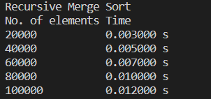

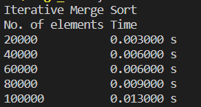

|  |  |  |
| --- | --- | --- |
| **Array Size** | **Time taken for merge sort (ms)** | |
| **Recursive** | **Iterative** |
| 20000 | 3 | 3 |
| 40000 | 5 | 6 |
| 60000 | 7 | 6 |
| 80000 | 10 | 9 |
| 100000 | 12 | 13 |

The recursive and iterative algorithms have taken roughly the same amount of time.

**Time Graph**